1. Write a select command that produces the order number, amount, and date for all rows in the Orders table.

Ans. mysql> select onum, amt, odate from orders;

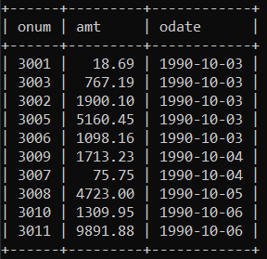

1. Write a query that produces all rows from the Customers table for which the salesperson’s number is 1001.

Ans. mysql> select * from salespeople where snum = 1001;

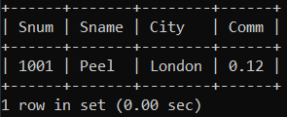

1. Write a query that displays the Salespeople table with the columns in the following order: city, sname, snum, comm.

Ans. mysql> select city, sname, snum, comm from salespeople;

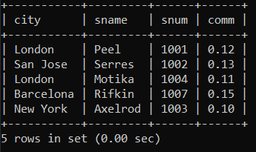

1. **Write a select command that produces the rating followed by the name of each customer in San Jose.**

**Ans. mysql> select rating, cname from customers where city = 'san jose';**

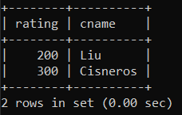

1. **Write a query that will produce the snum values of all salespeople (suppress the duplicates) with orders in the Orders table**

**Ans. mysql> select distinct snum from salespeople;**

